Controls

Dash/Platform Controls
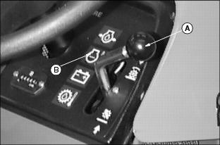
M87052
A - Mow/Lift Lever
B - Indicator Lights
C - Throttle Lever
D - PTO Switch
E - Glow Plug Switch
F - Light Switch
G - Weight Transfer Valve
H - Key
I - Park Brake Lever
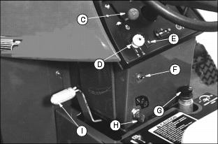
M79100

Foot Controls
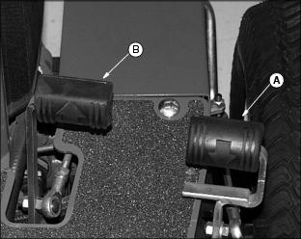
M99479
A - Reverse Travel Pedal
B - Forward Travel Pedal

Miscellaneous Controls
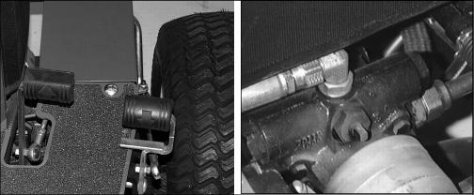
M99479, M78108
A - Free-Wheeling Lever
B - Fuel Shut-Off Valve
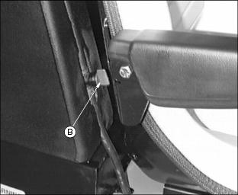

Adjusting Standard Seat
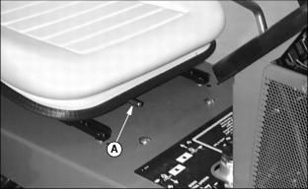
M78109
1. Push lever (A) to the left.
2. Slide seat forward or backward to desired position.
3. Release lever.

Adjusting Deluxe Seat

Select Seat Position
1. Move lever (A) out.
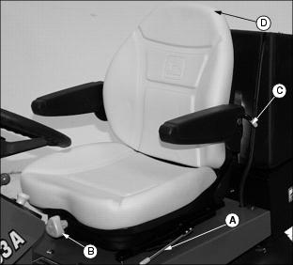
M97057
2. Slide seat forward or backward to desired position.
3. Release lever to lock seat in position. Make sure all controls can be easily accessed.

Adjust Ride Comfort
Adjust seat spring tension knob (B) to the weight of the operator, so that the seat "floats" in the center of it's travel as the machine traverses rough terrain.
1. Adjust seat suspension.
· Turn seat spring tension knob (B) to the right (clockwise) for a firmer ride.
· Turn seat spring tension knob (B) to the left (counterclockwise) for a softer ride.

Adjust Back Comfort
The back has three positions, from a straight upright position to a slightly inclined position.
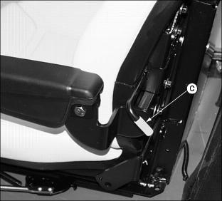
M99460
1. Place one hand on the back of the seat (D) and other hand on lever (C).
2. Gently pull forward or backward on the seat back (D) and lift lever (C) to lock in desired position and release.

Fuel Shut-Off Valve
IMPORTANT: Avoid damage! Never attempt to start engine with the fuel shut-off valve in the off position.

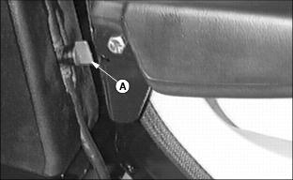
M78088
The fuel tank is equipped with a fuel shutoff valve (A). This valve should be closed if the machine is placed in extended storage. OFF is shown with the handle across the direction of the fuel line and ON is in the direction of the fuel line.

Park Brake
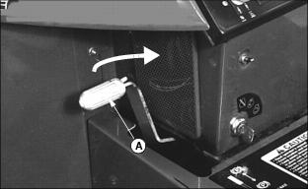
M79100
Engage the park brake (A) by pulling lever towards operator.
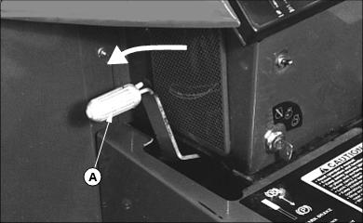
M79100
Disengage the park brake (A) by pushing lever away from operator.

Hydrostatic Ground Drive
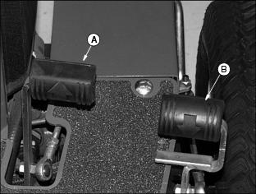
M99479
Depress forward (left) pedal (A) to move machine forward.
Depress reverse (right) pedal (B) to move the machine backward.

Mow/Lift Lever
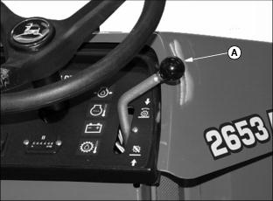
M97051
Pull lever (A) downward to raise cutting units and stop reel rotation. Hold in this position until the rear cutting unit is fully raised.
Push lever (A) forward to lower cutting units. If PTO switch is engaged, reels will begin to rotate when the cutting units are lowered.

PTO Switch
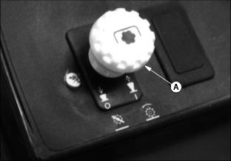
M56178
Push knob (A) down, to the OFF position to start engine. The maximum forward travel speed will increase when this is in the OFF position.
Pull knob up, to the ON position to mow. Reels will begin to rotate when lowered. Maximum forward speed will be limited to 5.0 m.p.h.

Throttle Lever
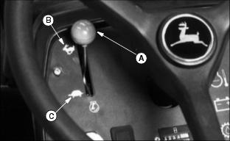
M56180
Push lever (A) forward against stop (B) to operate engine at FAST (r) idle.
NOTE: Always operate at full throttle for best mowing performance.
Pull lever downward against stop (C) to operate at SLOW (t) idle. Slow engine to idle before shutting off ignition.

Ignition Interlock System
For the starter to engage and the engine to run, the following conditions must be met simultaneously:
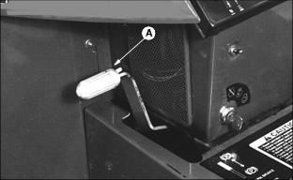
M79100
· Park brake (A) engaged. PTO switch (B) OFF. Hydrostatic ground drive pedals (C) in neutral.
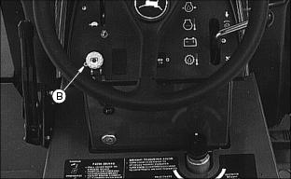
M56177
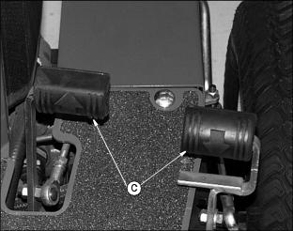
M99479
· If the operator is mowing (PTO switch on and/or ground drive engaged) and the operator leaves the seat the engine will stop.
· If the operator has stopped mowing (PTO OFF) and leaves the seat with ground drive in neutral, but without the park brake engaged, the engine will stop.
· If the operator attempts to drive forward or backward while the park brake is engaged, the engine will stop.
· Provisions have been made to allow a single operator to backlap the reels. (See Backlapping Cutting Units in Service-Cutting Unit Section.)

Starting The Engine
c CAUTION: Avoid injury! Start engine ONLY outdoors or in a well ventilated place. Exhaust fumes are dangerous. Make sure fuel shutoff valve is turned on
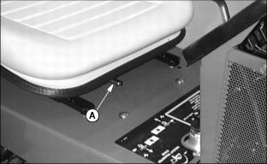
M78109
1. Move seat lever (A) to the left. Slide seat forward or backward to the most comfortable position.
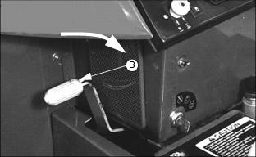
M79100
2. Engage the park brake by pulling lever (B) toward operator.
NOTE: Mower has an ignition interlock switch. Engine will not start unless:
· Park brake is engaged.
· PTO is OFF.
· Hydrostatic ground drive pedal is in neutral.
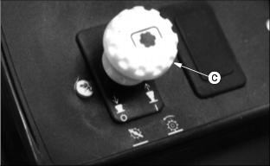
M56178
3. Push PTO switch (C) down to the OFF position.
4. Move throttle lever (D) to half speed position.
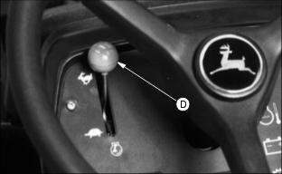
M56180
When key is in start position, all four indicator lights in the indicator module should come on.
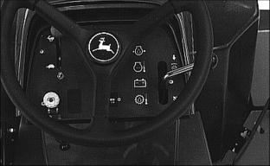
M56177
· Engine Oil Pressure
· Hydraulic Oil Temperature
· Battery Discharge Indicator
· Engine Coolant Temperature
If indicator lights do not come on in start position, see Troubleshooting section.
IMPORTANT: Avoid damage! DO NOT operate starter for more than 20 seconds at a time or damage may occur. If engine does not start, wait 2 minutes before trying again. If engine will not start, see Troubleshooting section.

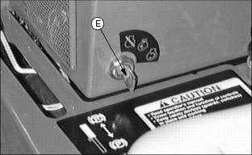
M78091
1. Turn key (E) to the START position.
2. When engine starts, release key to the RUN position.
3. Release the parking brake.

Checking Indicator Lights

After engine starts:
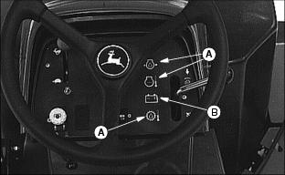
M56177
· Hydraulic oil temperature, engine oil pressure, and engine coolant temperature lights (A) should go out within 5 seconds.
· Battery discharge indicator (B) should go out within 10 seconds. If not, move throttle lever to 3/4 position.
If indicator lights stay on longer than given time, stop engine, find and correct problem. See Troubleshooting section.

Warming And Idling Engine
WARMING ENGINE:
· Run engine at half speed for 2 to 3 minutes.
IDLING ENGINE:
· The engine needs a large volume of air to keep cool. Keep grille and screens clean.
· Avoid unnecessary engine idling.

Stopping Engine
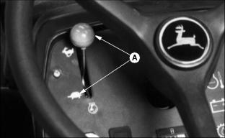
M56180
1. Move throttle lever down to SLOW (t) position (A). Let engine idle before stopping.
2. Engage the park brake.
3. Turn key to the OFF position.
4. Remove the key.

Glow Plug
Glow plugs preheat the engine for better starting performance.
1. Turn key switch to the run position.
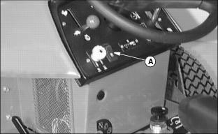
M78114
2. Depress and hold down glow plug switch (A) to an ON position.
3. After approximately 5-30 seconds release the glow plug switch and start the engine.
NOTE: Glow plug should be utilized when outside temperature reaches 0°C (32°F). The length of time the glow plug switch is depressed may be dependent on varying cold weather extremes.

Using Hydrostatic Transmission
IMPORTANT: Avoid damage! Run engine at full throttle for best performance.

1. Release the parking brake.
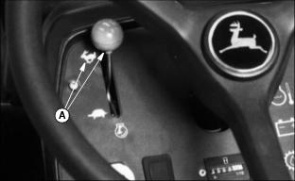
M56180
2. Move throttle lever all the way forward to FAST (r) position (A).
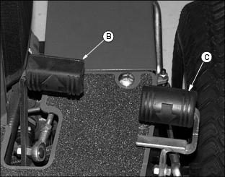
M99479
3. Slowly push hydrostatic control pedal (B) down to travel forward.
· The farther the pedal is pushed down, the faster the mower will travel.
· Push reverse pedal (C) down for Reverse.
Forward travel speed is 0-12.8 km/h (0-8 m.p.h.).
To travel in reverse:
· Allow forward pedal to slowly return to neutral.
· Check area behind mower.
· Slowly push reverse pedal (C) down to travel in reverse.
· The farther the pedal is pushed down the faster the mower will travel.
Reverse travel speed is 0-8.1 km/h (0-5 m.p.h.).

Emergency Stopping
c CAUTION: Avoid injury! Avoid quick stops.
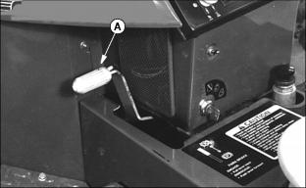
M79100
Remove foot from Hydrostatic Control Pedal.
Pull back on Park brake lever (A).

Using Free-Wheeling Lever
IMPORTANT: Avoid damage! NEVER tow mower faster than walking speed. The Free Wheeling mechanism is designed to allow manual movement when machine is not in operation. Hydraulic drive component damage will occur if the mower is towed, at high speed.

· Lift hinged cover plate on right side of engine.
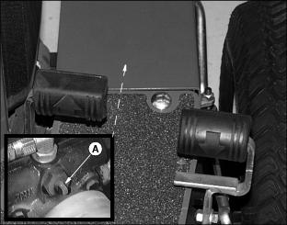
M78108, M99479
· Turn valve (A) horizontal to ENGAGE the Free Wheeling valve.
· Turn Valve (A) vertical (as shown) to DISENGAGE the Free Wheeling valve.

DAILY OPERATING CHECKLIST
 Test safety systems.
 Check tire pressure.
 Check fuel level.
 Check all oil levels.
 Check coolant level.
 Remove grass and debris from machine.

TESTING SAFETY SYSTEMS
c CAUTION: Avoid injury! Engine exhaust fumes can cause sickness or death.
· If it is necessary to run an engine in an enclosed area, remove the exhaust fumes for the area with an exhaust pipe extension.
· If you do not have an exhaust pipe extension, open the doors and get outside air into the area.

Checking Ignition Interlock Switches
Use the following procedure to check correct operation of the ignition interlock system. DO NOT operate the machine with a faulty system.

TEST 1
1. Sit on the seat.
2. Engage the parking brake.
3. Move the hydrostatic drive pedals to the NEUTRAL position.
4. Move the PTO switch to the ON position.
5. Turn key to the START position. Engine must not crank.
6. Turn key to the OFF position.
7. Move the PTO switch to the OFF position.
8. Turn key to the START position. Engine should crank.

TEST 2
1. Sit on the seat.
2. Engage the parking brake.
3. Move the PTO switch to the OFF position.
4. Move the hydrostatic drive pedal out of the NEUTRAL position.
5. Turn key to the START position. Engine must not crank.

TEST 3
1. Sit on the seat.
2. Move the PTO switch to the OFF position.
3. Release the parking brake.
4. Move the hydrostatic drive pedal to the NEUTRAL position.
5. Turn key to the START position. Engine must not crank.
6. Turn key to the OFF position.
7. Engage the parking brake.
8. Turn key to the START position. Engine should crank.

Using The Weight Transfer Control
c CAUTION: Avoid injury! DO NOT lift the reels on a slope or at fast speed. This could cause the machine to become unstable.
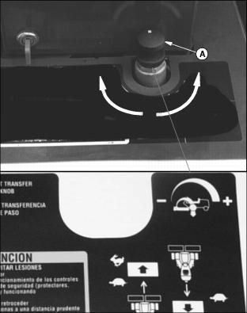
M56183a, M97044
Use the weight transfer control (A) to help improve traction.
To transfer some of the mower weight to the drive wheels:
· Turn the knob clockwise to activate weight transfer and add weight to the drive wheels.
NOTE: If knob is turned enough clockwise, the reels will lift off the ground.
· Turn the knob counterclockwise to reduce weight to the drive wheels.
· Turn the knob fully counterclockwise to deactivate weight transfer.

Avoid Damage To Plastic And Painted Surfaces
· Insect repellent spray may damage plastic and painted surfaces. Do not spray insect repellent near machine.
· Be careful not to spill fuel on machine. Fuel may damage surface. Wipe up spilled fuel immediately.

Cutting Taller Grass (Front Rollers Are Optional)
IMPORTANT: Avoid damage! When mowing tall grass in rough terrain, it is recommended to leave the front rollers on to protect the reels from striking any unseen objects.

When cutting grass taller than approximately 38 mm (1-1/2 in.), the front roller tends to knock down grass affecting the quality of cut. In these conditions, it may be necessary to operate with cutting units in fixed position without a roller.
NOTE: The fixed position is recommended for smooth areas only, such as athletic fields, level parks, etc.
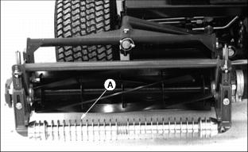
M56207
1. Remove front roller (A).
2. Remove scraper, if equipped.
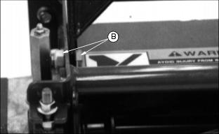
M56202
3. Install 1/2 x 1 in. cap screw, and nut, from bag of hardware supplied with machine, to fixed position (B) on both sides of all three cutting units.

Cutting Shorter Grass
When cutting grass under approximately 38 mm (1-1/2 in.) Place the cutting unit in the floating position.
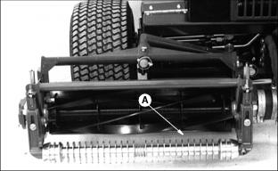
M56207
1. Install front roller (A).
2. Install scraper, if equipped. (See instruction sheet provided for scraper kit).
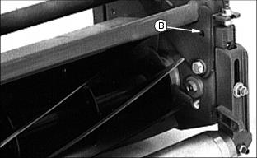
M56203
3. Remove 1/2 x 1 in. capscrew and nut from fixed position (B).
NOTE: Cutting grass under 38 mm (1-1/2 in.) in dry conditions a grooved roller may be desirable.
In wet/muddy conditions or in new growth areas a smooth roller may be the choice.

Grass Deflector
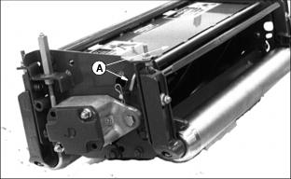
M56237
The cutting units come with a grass deflector mounted on the rear of the cutting units.
NOTE: For ease of changing, the bent end of rod (A) should be located opposite the motor end of the cutting units.
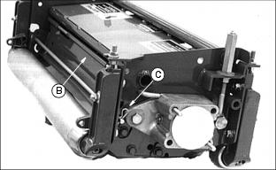
M56238
With the deflector (B) down as shown the grass will be deflected towards the front of the cutting units.
Remove pull pin (C) and rod (A) and move deflector (B) up, to position shown for rear discharge of grass clippings.
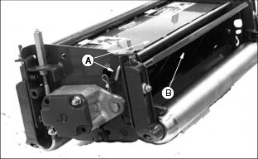
M56237
Replace rod (A) and pull pin (C).

Engaging Reel Drive
IMPORTANT: Avoid damage! Run engine at full throttle for best performance.

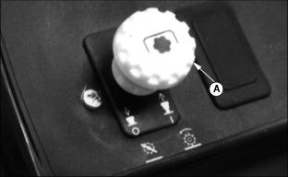
M56178
1. Pull PTO switch (A) up to on position.
2. Move throttle all the way forward to FAST (r) position.
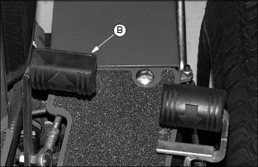
M99479
3. Slowly push pedal (B) down to begin forward mowing
4. Push Lift/ Mow lever (C) forward to lower cutting units and start reel rotation.
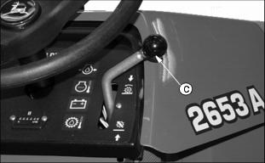
M97051
5. Pull Lift/Mow lever (C) back to raise cutting units and stop reel rotation. Hold in this position until the rear cutting unit is fully raised.
6. Remove foot from pedal (B) to stop forward travel.

Dismounting To Inspect Or Unplug Reels
c CAUTION: Avoid injury! Avoid injury from contacting blades. Before you dismount to unplug or service cutting units:
·
· STOP the engine.
· LOCK the park brake.
· DISENGAGE cutting units to stop reels.
· Remove key.
· Wait for reels to STOP.
· Keep hands, feet and clothing away from cutting units when engine is running.
· Shut off PTO when you are not mowing.
NOTE: If engine and cutting units are running, engine and cutting units will stop when operator lifts off seat, if the park brake is not set.
1. Stop the machine.
2. Engage the park brake.
3. Push the PTO switch down to the OFF position.
4. Lower the cutting units to the ground.
5. Stop the engine.
6. Remove the key.

7Grease All Locations Every 50 Hours
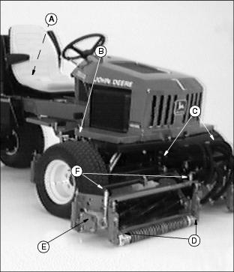
M87049
A - Grease rear wheel pivot (Move seat forward.)
B - Cam Follower
C - Grease lift arms in six (6) places.
D - Grease six (6) front and rear roller bearings.
E - Grease six (6) reel bearings.
F - Grease adjusters in six (6) places.
G - Grease eccentric in two (2) places on neutral start. (Lift cover plate on right side of engine. Look under right hand side of machine under the footrest.)
H - Grease rear wheel Steering Arm in two (2) places.
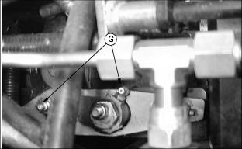
M79105
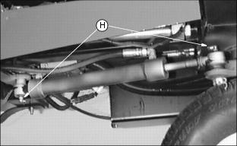
M77034
. Wait until all moving parts have stopped.

Checking Engine Oil Level
IMPORTANT: Avoid damage! Engine must NOT be running.

NOTE: Check oil twice a day if engine is run over 4 hours a day.
1. Park on a level surface.
2. Stop the engine.
3. Check engine oil when oil is cold.
4. Lift the hood. (See Raising Hood in Service-Miscellaneous section)
5. Remove plenum.
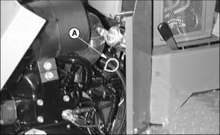
M60919
6. Clean around dipstick. Remove dipstick (A).
7. Install dipstick in tube.
8. Remove dipstick. Check oil level on dipstick.
IMPORTANT: Avoid damage! If oil level is BELOW ADD mark or ABOVE FULL mark, DO NOT run the engine.

9. Oil must be between ADD and FULL marks.
10. If oil level is low, add oil to bring oil level no higher than FULL mark on dipstick. (See Engine Oil in this section for correct oil.)
11. Install the dipstick. Lower the hood.
12. If oil level is above full mark, drain to the proper level. Determine cause of over-full condition and correct.

Changing Engine Oil And Filter
NOTE: Access to oil filter and drain plug is improved by disconnecting the center cutting unit from the lift arm and sliding it out of the way.
1. Run engine to warm the oil.
2. Park mower on level surface and lower cutting units.
3. Stop the engine. Lock the park brake and remove the key.
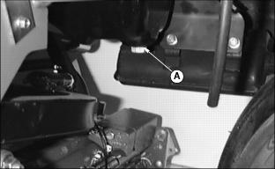
M73901
4. Remove drain plug (A) to drain oil.
5. Remove oil filter (B) (not shown). Turn filter counterclockwise to remove.
6. Apply a film of clean engine oil on seal of new filter.
7. Install filter. Turn filter until seal contacts mounting surface. Tighten 1/2-3/4 turn after gasket contact.
8. Install drain plug.
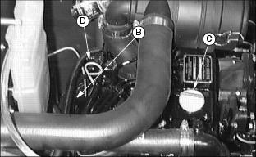
M72517
9. Remove filler cap (C). Add approximately 2.4 L (2.5 qt) of oil. (See Engine Oil in this section for correct oil.)
10. Remove the dipstick (D) to check oil level.
11. Install and tighten the filler cap.
12. Run engine at slow speed 2 minutes. Check for leaks around filter.
13. Stop the engine and wait a couple of minutes. Check oil level. Add oil only to FULL mark on dipstick.
14. Install the dipstick.

Cleaning Plenum Air Intake Screens
IMPORTANT: Avoid damage! Plenum intake screen must be clear of dirt and debris to prevent engine from overheating.

1. Stop the engine. Lock the park brake and remove the key.
2. Raise the hood.
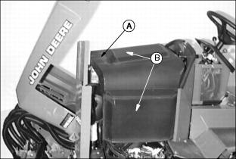
M87058
3. Remove plenum (A) by lifting up and away from engine.
4. Clean plenum air intake screens (B) (top and sides) with brush or compressed air.

Checking Air Restriction Indicator
1. Stop the engine. Lock the park brake and remove the key.
2. Raise hood.
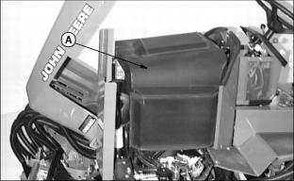
M87058
3. Remove plenum (A).
NOTE: Indicator will not signal correctly if indicator case is cracked or broken.
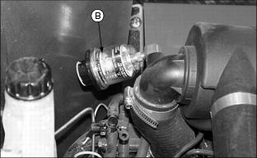
M97045
4. Check air restriction indicator: When yellow plunger (B) inside indicator shows in clear window, air cleaner requires immediate service. (See Replacing Air Cleaner Element in this section.)
5. Install plenum (A)
6. Lower the hood.

Replacing Air Cleaner Element
IMPORTANT: Avoid damage! DO NOT clean primary air cleaner element, replace it when air restriction indicator reaches red line.
DO NOT raise canister upward when removing primary and secondary elements. Dirt can fall into the intake manifold and could cause engine damage

1. Stop the engine.
2. Lock the park brake and remove the key.
3. Lift the hood.
4. Remove plenum.
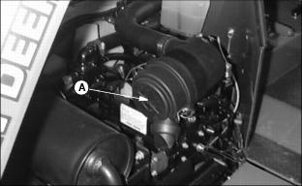
M87059
5. Unclip and remove air cleaner canister cover (A).
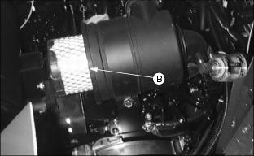
M60918
6. Remove and discard old primary element (B).
IMPORTANT: Avoid damage! DO NOT clean secondary element.
Replace secondary element only every third primary element change, every two years, or when air restriction indicator shows yellow in the window, after replacing the primary element.

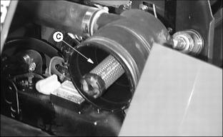
M77038
7. Remove and discard if necessary the secondary element (C).
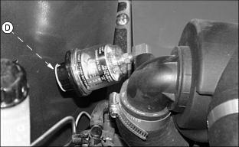
M97045
8. Depress and release reset button (D) on bottom to reset air restriction indicator.
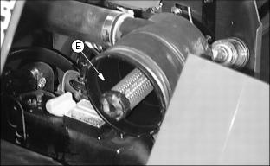
M77038
9. Install secondary element (E). Push on securely.
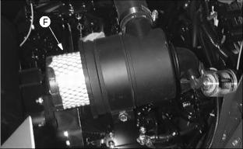
M60918
10. Install new primary element (F), push on securely.
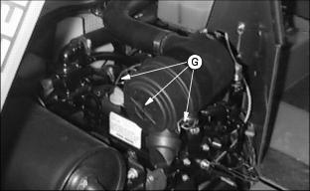
M87059
11. Install cover and engage latches (G).
12. Install plenum
13. Lower hood.

Clean Rubber Dust Unloading Valve
IMPORTANT: Avoid damage! Never operate engine without air cleaner elements and rubber dust unloading valve installed.

Remove rubber dust unloading valve (A) and clean. Replace if damaged.
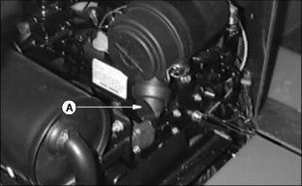
M87059

Service Cooling System Safely
c CAUTION: Avoid injury! Explosive release of fluids from pressurized cooling system can cause serious burns:
· Shut off engine.
· Only remove filler cap when radiator is cool enough to touch with bare hands. Slowly loosen cap to first stop to relieve pressure before removing completely.

Engine Coolant
IMPORTANT: Avoid damage! To prevent engine damage:
· DO NOT use pure antifreeze or more than 50% antifreeze in the cooling system.
· DO NOT mix or add any other type additives to the cooling system.

Use ethylene glycol base coolant. These coolants usually have labels stating "For Automobile and Light Duty Service." These products are also often labeled for use in aluminum engines. Check container label before using.
Mix approximately 50 percent antifreeze with 50 percent distilled or deionized water. This mixture will provide freeze protection to -37 degrees C (-34 degrees F).
Certain geographical areas may require lower temperature protection. See the label on your antifreeze container or consult your John Deere distributor to obtain the latest information and recommendations.
The recommended antifreeze provides:
· Adequate heat transfer.
· Corrosion-resistant environment within the cooling system.
· Compatibility with cooling system hose and seal material.
· Protection during cold and hot weather operations.

Checking Coolant Level
IMPORTANT: Avoid damage! To prevent engine damage:
· DO NOT operate engine without coolant.
· DO NOT pour coolant into the radiator when the engine is hot.
To prevent engine overheating:
· Never exceed more than 50 percent antifreeze in cooling system.
Cooling system capacity: 4.15 L (4.25 qt) plus 532 mL (18 oz.) in the overflow tank.

1. Lift hood.
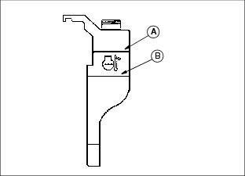
M71498
2. Check coolant level:
· If engine is warm, coolant should be between lines (A) and (B) on coolant tank.
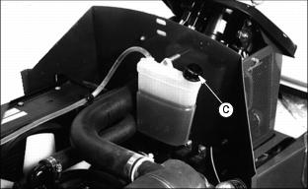
M78140
3. Remove cap (C) to add coolant.
4. If coolant is low, add ethylene glycol (without stop-leak additive) antifreeze and water in the ratio specified on the antifreeze container.
5. Install and tighten recovery tank cap.
6. Clean debris from air intake screen and radiator.
7. Check condition of hoses. Check for leaks or loose connections.

Draining Cooling System
c CAUTION: Avoid injury! Explosive release of fluids from pressurized cooling system can cause serious burns:
· Shut off engine.
· Only remove filler cap when radiator is cool enough to touch with bare hands. Slowly loosen cap to first stop to relieve pressure before removing completely.
1. Stop the engine and let it cool.
2. Raise the hood.
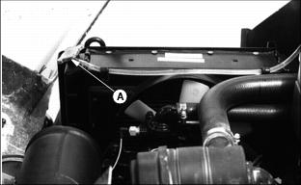
M78102
3. Slowly remove radiator cap (A).
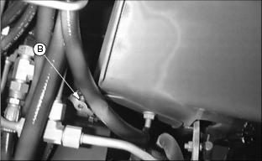
M72519
4. Open radiator petcock (B). Drain coolant into a bucket.
5. After all coolant has drained, close radiator petcock.
6. Flush cooling system. (See Flushing Cooling System in this section.)

Flushing Cooling System
c CAUTION: Avoid injury! Engine and coolant will be hot.
Turn radiator cap using a thick rag or glove to protect your hand.

IMPORTANT: Avoid damage! To prevent engine damage:
· DO NOT pour water into a hot engine.
· DO NOT operate engine without coolant.

1. Fill cooling system with clean water and John Deere Cooling System Cleaner, or John Deere Cooling System Quick Flush or an equivalent. Follow directions on the can.
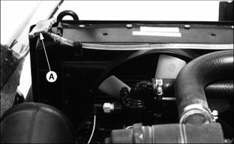
M78102
2. Install and tighten radiator cap (A).
3. Start and run engine until it reaches operating temperature. Stop engine.
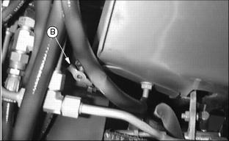
M72519
4. Open radiator petcock (B) and drain the cooling system immediately before rust and dirt settle.
5. Close radiator petcock.

Filling Cooling System
IMPORTANT: Avoid damage! To prevent engine damage:
· DO NOT use straight antifreeze or more than 50% antifreeze in the cooling system.
· DO NOT mix or add any other type additives to the cooling system.
Cooling system capacity: 4.15 L (4.25 qt.).

1. Fill cooling system. For cold weather, use a solution of only ethylene glycol antifreeze (without a stop-leak additive) and clean, soft water. A chart on the antifreeze container tells how much antifreeze to use for the freeze protection needed in your area.
John Deere Cooling System Sealer or its equivalent may be added to the radiator to seal leaks. Do not use any other additives in the cooling system.
2. Install and tighten radiator cap.
3. Run engine until it reaches operating temperature.
4. Stop the engine.
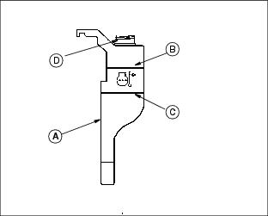
M71498
5. After the engine cools, check coolant level in recovery tank (A). Level should be up to H mark (B) on tank when engine is hot or L mark (C) on tank when engine is cold.
6. Remove cap (D) to add coolant if necessary.
7. Check condition of coolant system hoses. Install new hoses periodically. Tighten hose clamps regularly.

Checking Sediment Bowl
c CAUTION: Avoid injury! Keep cigarettes, sparks, and flames away from fuel system. Be sure engine is cool.
Wait until fuel is low before replacing fuel filter OR be prepared to drain fuel into a safe container when disconnecting hose.
1. Stop the engine. Raise the hood.
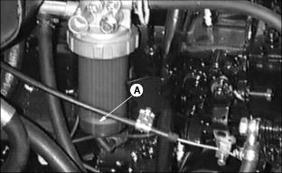
M73894
2. Check for water in sediment bowl (A): Orange ring will float on top of the water.
3. If necessary, clean bowl and replace filer. (See Cleaning Fuel Filter Sediment Bowl in this section).

Cleaning Fuel Filter Sediment Bowl
1. Raise the hood.
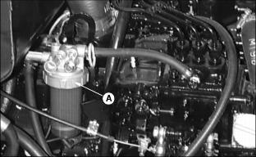
M73894
2. Turn collar (A) to remove bowl and filter. Discard the filter.
3. Clean the bowl.
4. Install new filter and bowl.
5. Tighten collar.
6. Lower the hood.

Bleeding Fuel System
c CAUTION: Avoid injury! Escaping fluid under pressure can penetrate the skin causing serious injury. Avoid the hazard by relieving pressure before disconnecting hydraulic or other lines.

IMPORTANT: Avoid damage! DO NOT service injectors or injection pump. Special training and tools are required. See your John Deere distributor.

1. Stop the engine.
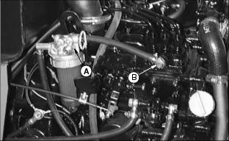
M73915
2. Loosen bleed screws (A) and (B).
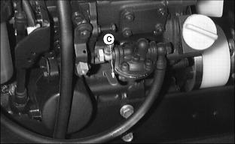
M78141
3. Pump lever (C) until fuel flows from around screws.
4. Tighten screws when fuel flows free of bubbles.
5. Start the engine.
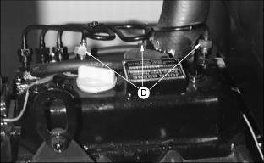
M73914
6. If engine does not run smoothly, loosen three fuel line fittings (D) one at a time.
7. Tighten fittings when fuel flows free of bubbles.

Transmission And Hydrostatic Oil
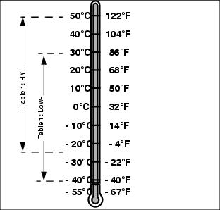
MIF
Use oil viscosity based on the expected air temperature range during the period between oil changes.
John Deere HY-GARD® is recommended.
Other oils may be used if they meet the following:
John Deere Standard JDM J20C.
Use type F Automatic Transmission Fluid or John Deere All-Weather Hydrostatic Fluid.

Checking Hydraulic Oil Level
IMPORTANT: Avoid damage! Engine must not be running.

1. Park on a level surface.
2. Lower cutting units to the ground.
3. Stop the engine.
4. Check oil level when oil is cold.
NOTE: Fill tube is behind seat.
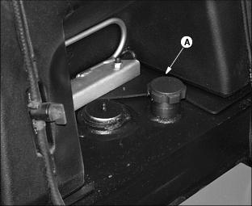
M97052
5. Pull dipstick (A) out to check oil level.
6. If oil level is low, add John Deere HY-GARD oil or an equivalent. (See Hydostatic Drive Oil in this section.)

Change Hydrostatic Drive Oil
c CAUTION: Avoid injury! Hydraulic Oil reservoir can get hot so use caution when filling and draining oil.

IMPORTANT: Avoid damage!
· Prevent dirt from getting in reservoir.
· Change hydrostatic drive oil and filter after first 50 hours of break-in operation.
· Change hydrostatic oil and filter at 200 and 400 hours or yearly which ever comes first.

1. Park on a level surface.
NOTE: Drain plug is located left rear of machine below fuel tank.
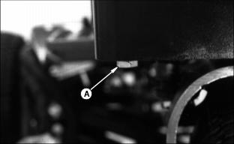
M56218
2. Remove plug (A) and drain oil into a drain pan with at least a 6 gal capacity.
3. Install plug.
4. Fill reservoir with approximately 20.8 L (5.5 gal) of oil. Use John Deere HY-GARD oil or an equivalent oil meeting John Deere specifications (See Service Hydrostatic Oil in this Section.)
5. Start the engine. Cycle hydraulic control for 1 or 2 minutes.
6. Stop the engine and check oil level. Add oil as necessary.(See Checking Hydraulic Oil Level in this section).

Replacing Hydrostatic Oil Filter
1. Stop the engine. Engage the parking brake.
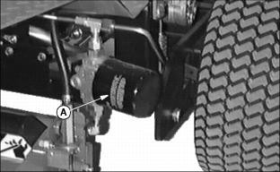
M78096
2. Turn hydraulic oil filter (A) counterclockwise to remove. Use drain pan to catch dripping oil.
3. Put a film of clean oil on seal of new filter.
4. Tighten filter until it contacts mounting surface. Tighten filter one full turn after gasket contact. A filter wrench may be required.
5. Start the engine and check for leaks.
6. Stop engine and check oil level. Add oil as necessary. (See Checking Hydraulic Oil Level in this section).

Adjusting Height-Of-Cut
c CAUTION: Avoid injury! DO NOT service or adjust machine while engine is running.
NOTE: All cutting units must be set at the same height to obtain an even cut. Floating units will not provide a quality cut in grass over approximately 38 mm (1-1/2 in.) tall.
c CAUTION: Avoid injury! Reels are sharp and may cause injury to one's body, always wear gloves when manually rotating reel. Rotating one reel by hand may cause other reels to rotate. If a reel is rotated, be sure no other person is near the other units.
1. Adjust reel-to-bed knife. (See adjusting Reel-To-Bed Knife in this section).
2. Raise cutting units or remove as desired.
3. Shut off the engine.

To raise rollers:
NOTE: Rear rollers come from factory set and leveled at 19 mm (3/4 in.) cut.
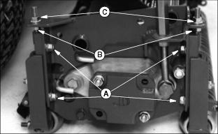
M56226
1. Loosen bolts (A),
NOTE: If rollers are adjusted to a position so gauge bar cannot be installed, raise either the front or rear roller or both to allow installation of the gauge bar.
2. Loosen bottom adjusting nuts (B).
NOTE: Each notch in the adjuster rack equals 3.2 mm (1/8 in.). Set rear roller first and then front roller.
3. Turn top adjusting nut (C) clockwise on each end of cutting unit, alternating back and forth.
NOTE: Height-of-cut has two general height settings 9.5-41 mm (3/8-1-5/8 in.) and 38-89 mm (1-1/2-3-1/2 in.).
4. If adjustment is limited by slots at (A) then raise or lower each adjuster one notch as needed to every adjuster.
NOTE: Adjusters MUST be installed with carriage bolt in top hole (D) (stud end) for H.O.C. lower than 38 mm (1.5 in.), and the bottom hole (E) for H.O.C. greater than 38 mm (1.5 in.).
See front roller instruction sheet for hole selection.
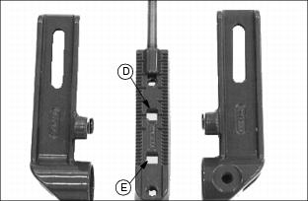
M56130
5. Use a two bolt gauge bar.
NOTE: Using a single-bolt adjusting gauge bar will not ensure parallelism between rollers and may result in uneven height-of-cut.
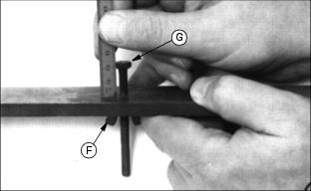
M47195
6. Loosen wing nut (F). Set height-of-cut by measuring from the top of the gauge to the bottom of the head of the bolt (G). Lock wing nut (F).
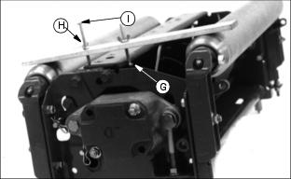
M56227
Picture Note: (Cutting unit is upside down for photo clarity)
7. Hook head of bolt (G) over edge of bed knife.
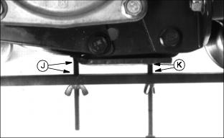
M47250
8. Loosen wing nut (H). Turn bolt (I) until gauge is parallel with bed knife. Measure distance between front (J) and rear (K) of the bottom of the bed knife to top of gauge. Distance should be the same.
IMPORTANT: Avoid damage! DO NOT turn nuts on front adjuster beyond where the roller just touches the gauge bar or the bar will bend.

NOTE: When adjusting rollers, move both ends of roller equally, alternating from end to end. This will keep the adjusters from binding
9. Loosen top adjusting nuts.
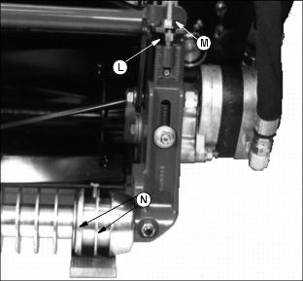
M56225
10. On grooved rollers, carefully turn bottom adjusting nut (L), after loosening top nut (M), until the first 2 ribs (N) of the machined portion of the roller just touches the gauge.
This is determined by turning the roller and listening for the scratching sound from roller on gauge bar.
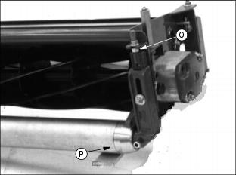
M56228
11. On solid rollers, carefully turn bottom adjusting nut (O) until the solid center piece of the roller (P) (not the end caps) just touches the gauge.
This is determined by turning the roller and listening for the scratching sound. On rollers with scrapers, a screwdriver can be inserted in slot of the scraper to lift it out of the way to better clean the scraper and roller. Hook the screwdriver handle under the reel housing to hold the scraper.
12. After setting front and rear rollers on one end, lock jam nuts and recheck all gauge settings. Readjust if necessary.
13. Follow same procedure for the other end of bed knife and rollers.
14. After setting second end, go back and check first settings to be sure they haven't moved. Readjust if necessary. Gauge can snugly be placed into position on either end when properly adjusted.
NOTE: Cutting units with no front roller (fixed position) set rear roller only.

Adjusting Reel-To-Bed Knife Clearance
This adjustment, combined with the backlapping operation, will ensure a clean cut as well as reduce wear, take less power, and reduce down time.
Reel-to-bed knife clearance should be checked BEFORE and AFTER backlapping.
c CAUTION: Avoid injury! Always wear gloves when manually rotating reel.
Rotating one reel by hand may cause other reels to rotate. If a reel is rotated, be sure no other person is near the other units.
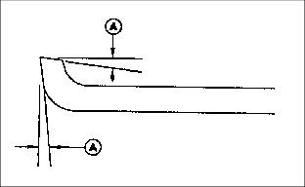
M47199
1. The cutting edge of the bed knife must be sharp and straight, and the relief angle should be 5 degrees (A) as shown.
Otherwise, remove bed knife and bed knife support and have them ground as a complete unit.
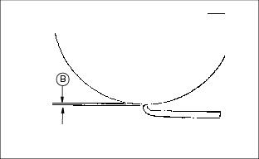
E35559
2. Use feeler gauges to set recommended reel-to-bed knife clearance (B) in the range for the grass to be cut.
Finer textured grasses, such as rye grass or bent grass require a close setting, but the setting should not be less than 0.05 mm (0.002 in.). They also require a sharp reel and bed knife to cut properly.
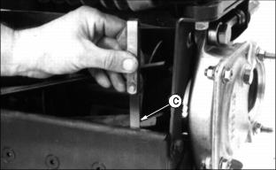
M47200
3. Place a 0.05 mm (0.002 in.) feeler gauge (C) between bed knife and reel. Check at both ends of reel and 2 areas near the center.
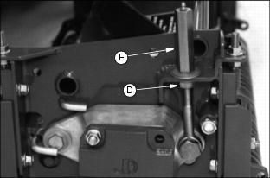
M56226
4. If adjustment is necessary, loosen jam nut (D) and adjusting nut (E) at both ends of the reel, equal amounts, preferably one flat at a time.
· Turn adjusting nuts (E) clockwise to raise reel.
· Turn jam nut (D) clockwise to lower reel.
· Adjust reel until 0.05 mm (0.002 in.) is reached across the entire reel and bed knife.
IMPORTANT: Avoid damage! DO NOT allow the reel to interfere with the bed knife. Interference will cause heating and can damage reel and bed knife.

5. Tighten adjusting nuts (E) and jam nuts (D). Recheck to ensure reel has not moved. Readjust if necessary.

Adjust Lift Arm Bumper Stops
NOTE: Make this adjustment to prevent unnecessary movement of lift arms and cutting units during transport.
1. Start engine.
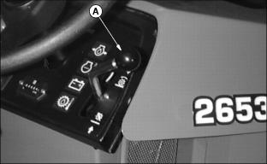
M87063
2. Pull Lift/Mow lever (A) back to raise lift arms and attached cutting units to a maximum raised position.
3. Stop engine.
NOTE: One stop bolt and one stop per cutting unit.
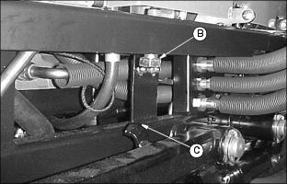
M99462
4. Locate adjustable lift arm bumper stop bolt (B) mounted vertically under each side of the bumper.
5. Adjust bolts individually up or down to allow 3 mm (.12 in.) maximum lift arm movement at each stop (C).

Backlapping Cutting Units
IMPORTANT: Avoid damage! The reel-to-bed knife clearance should be adjusted to approximately 0.076 mm (0.003 in.) at the ends.

Backlapping cutting units must be done on a routine basis to prolong reel life, prevent downtime, and provide sharp cutting action.
1. Set park brake and start engine.
2. Lower all cutting units to the ground.
c CAUTION: Avoid injury! Avoid injury from rotating blades. Keep hands and feet away while machine is operating.
NOTE: Cutting units are backlapped all at once.
3. Lift the cover plate on the left side of the engine to expose the Backlapping valve.
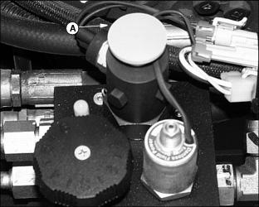
M97053
4. Put machine in backlapping mode by pulling up on the Forward/Reverse knob (A).
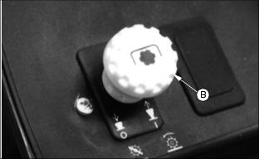
M56178
5. The PTO switch (B) can now be pulled up to ON while the operator is on or off the machine. The reels will turn backward.
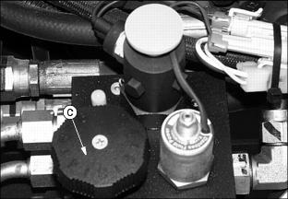
M97053
6. Rotate the flow control knob (C) to adjust the reel speed. Turn the knob clockwise to decrease the reel speed, to the left or counterclockwise to increase reel speed.
7. Adjust reel speed slowly enough so grinding compound will not be thrown off during backlapping.
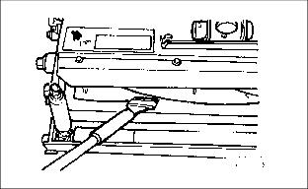
M79054
8. Using a long handled brush, carefully apply reel sharpening compound, uniformly, from one end of the reel to the other.
Repeat application in opposite direction. Allow unit to continue running backwards until reel is quiet.
9. Periodically disengage PTO switch and shut engine off to visually check blade appearance.
10. Wash away backlapping compound before checking reel-to-bedknife clearance.
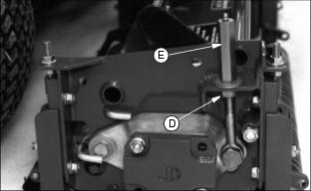
M56226
11. Adjust reel-to-bed knife clearance by loosening jam nut (D) and turning adjusting nut (E) and jam nut (D) to proper clearance on both ends.
Check for uniform clearance across entire bed knife. If clearance is not uniform, repeat steps 5 thru 11 until clearance is uniform across entire bed knife.
IMPORTANT: Avoid damage! Turn flow control knob fully counterclockwise when the backlapping operation is complete.

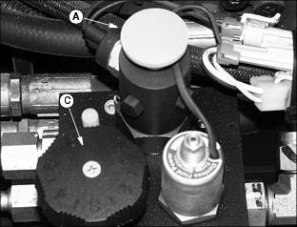
M97053
12. Disengage PTO switch and shut off engine. Turn flow control knob (C) fully counterclockwise.
IMPORTANT: Avoid damage! Do not operate units in the forward direction until reel sharpening compound is washed from the unit. Unless properly washed, the reels can be dulled by the compound.

13. Push Forward/Reverse knob (A) down to resume normal operation.

Readjust Reel-To-Bed Knife Clearance
See Adjusting Reel-to Bed Knife Clearance in this section.

Grinding The Bed Knife
NOTE: Bed knife removed for illustration purposes only.
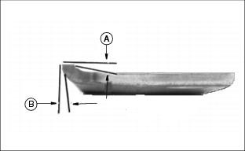
E28691
When grinding the bed knife, it is important to have a 5 degree relief angle on top surface (A) and front surface (B).

Replacing Bed Knife
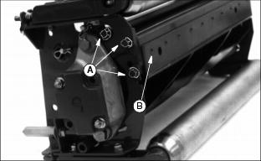
M56224
1. Remove six cap screws (A) attaching bed knife support to cutting unit housing, three on each end.
2. Remove bed knife support, with bed knife attached from cutting unit housing.
3. Remove and discard screws and nuts attaching bed knife to support. Discard bed knife.
4. Remove debris, corrosion, and rust from bottom surface of bed knife support.
5. Install end screws (B), tighten to secure knife to support, to properly position knife.
6. Install rest of screws and nuts.
7. Torque nuts to 1/2 torque, approximately 26 N·m (19 lb-ft.), starting from the center and work out towards the ends.
8. Finish torquing to full torque,45 N·m (34 lb-ft), starting from the center and work out towards the ends. Minimum torque is 35 N·m (26 lb-ft).
9. Put bed knife support and bed knife in a suitable grinder and grind until knife is flat and uniformly ground across the top surface.
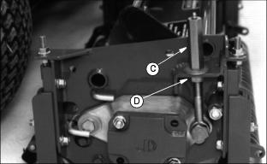
M56226
10. Raise reel, by turning the reel adjusting nut (C) clockwise and nut (D) counterclockwise, until the knife and support can be installed.
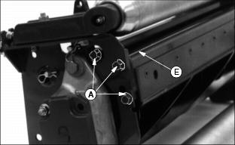
M56224
11. Reinstall the bed knife support assembly, and snug cap screws (A) on both ends.
12. Tap both ends of bed knife (E) away from reel with a brass hammer to remove any play in bed knife support. Tighten cap screws to 43 N·m (32 lb-ft.).
13. Set the height-of-cut. See Adjusting Height-Of-Cut in this section.
14. Adjust the reel-to-bed knife. See Adjusting Reel-To-Bed knife in this section.
15. Backlap reel. See Backlapping Cutting Units in this section.
16. Check the height-of-cut and adjust as necessary. See Adjusting Height-Of-Cut in this section.

Replacing Fuses
1. Raise the hood and open the fuse holder.
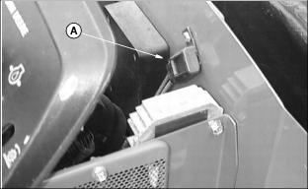
M77244
2. Pull fuse (A) out of socket. A metal clip in the fuse will be broken if defective.
3. Push new 20 amp fuse into socket. Be sure to replace fuse with same amperage. (See your John Deere distributor or an automotive parts store for fuse replacement.)

Replacing Indicator Light Bulb
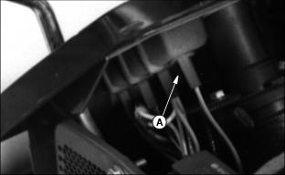
M56190
1. To remove bulbs use a 1/4 turn counterclockwise of the bulb holder (A).
2. Pull the burnt out bulb straight out: DO NOT twist.
3. Push the new bulb straight in.
4. Install bulb holder with a 1/4 turn clockwise twisting motion.

Adjusting Parking Brake
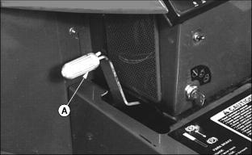
M79100
1. To adjust park brake tension, place park brake (A) in the DISENGAGED position.
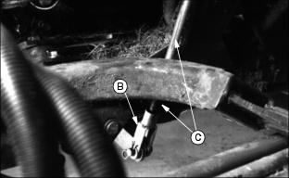
M79109
2. Tighten the yoke (B) so the brake pads just begin to drag on the brake rotor. Then back off one revolution.
3. When all yoke adjustments have been used, back off the yoke so the threads on the rod (C) are flush with the yoke.
IMPORTANT: Avoid damage! Do not loosen top nut (G) until spring is loose. If top nut is backed off too far, spacer on inside of spring may jump out of hole in spring bracket and bind up brake when top nut is tightened.

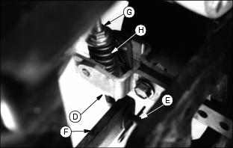
M79108
4. Loosen top nut (G) approximately 1/4 inch.
5. Remove hairpin clip from end of "J" rod (E).
6. While holding caliper arm with spring assembly, up as far as possible adjust "J" rod until end of rod aligns with hole in brake lever arm (F).
7. Reassemble "J" rod, washer, and hairpin clip (E).
8. Tighten top nut (G), while holding bottom nut (D), until it contacts spacer. Torque to 10 N·m (7 lb-ft).
9. Engage the brake and repeat on opposite side.

Cleaning Equipment Properly After Use
Following are general guidelines for the daily cleaning of John Deere Golf & Turf Equipment:
1. Lower attachments to the ground.
2. Disengage all power and stop the engine.
3. Move hydraulic lif levers back and forth to relieve pressure.
4. Lock park brake and remove the key.
c CAUTION: Avoid injury! Avoid personal injury. Reduce compressed air to less than 210 kPA (30 psi) when using for cleaning purposes. Clear area of bystanders, guard against flying chips, wear personal protection equipment including eye protection.
5.
IMPORTANT: Avoid damage! Avoid machine damage!
· Compressed air should be used to clean ALL radiators and air screen. DO NOT use water when cleaning these areas.
· DO NOT use water to wash under hood or under seat area or where electrical components are located. Use compressed air and blow debris away. Water in electrical connections may create electrical problems.
· Do not direct high pressure water at the reel motor seals. Water may be drawn into bearings as they cool.

6. Blow debris from radiators, air screens, under the hood and seat area using compressed air.
7. Wash exterior of machine, foot platform area and reels using high volume, low pressure water.
8. Perform grease maintenance on the reels after washing to purge any moisture from system.

Care for Plastic and Painted Surfaces

PLASTIC SURFACES
The plastic parts on your greensmower are made of a blend of polycarbonate and polyester materials. These parts are extremely strong and durable. Unlike painted metal, the plastic parts will never dent or rust. If the plastic parts get scratched, the color will remain the same since the color goes through the entire part.
IMPORTANT: Avoid damage! "Dry wiping" or wiping the plastic surface when it is dry will result in minor surface scratches. Always wet the surface before cleaning. Follow correct cleaning and waxing procedures.

NOTE: Follow cleaning procedure every time plastic surfaces are cleaned. DO NOT wipe dry plastic surface with hand or towel.

Correct Cleaning Care:
1. Before washing, rinse hood and entire machine with clean water to remove dirt and dust that may scratch the surface.
2. Wash plastic surface with clean water and a mild liquid automotive washing soap. Use a SOFT, CLEAN cloth (bath towel or automotive mitt) when washing.
3. Dry thoroughly with a SOFT, CLEAN cloth (diaper or bath towel).
4. Wax the surface with a liquid automotive wax. Use products that specifically say "contains no abrasives".
5. Remove applied wax by hand using a clean, soft cloth.

Avoid Damage:
· "Dry wiping" or wiping the plastic surface when it is dry is a major source of minor surface scratches.
· DO NOT wipe hood or other plastic parts unless wetted first.
· DO NOT apply wax unless plastic surface has been thoroughly cleaned first.
· DO NOT use abrasive materials, such as polishing compounds, to clean or to wax plastic surface.
· DO NOT wax plastic surfaces without drying first. Hard-to-remove water spots will be left.
· DO NOT use solvents or commercial cleaners.
· DO NOT use power buffers to remove wax.
· DO NOT spray insect repellent near machine. Insect repellent spray may damage plastic or painted surfaces.
· Be careful not to spill fuel on any plastic or painted surfaces. Wipe up fuel immediately.

Repair:
· Your John Deere dealer has the professional materials needed to properly remove surface scratches from any plastic surfaces.
· DO NOT attempt to paint over marks or scratches in plastic parts.
· DO NOT use polishing compounds to attempt to remove scratches.

PAINTED METAL SURFACES

Correct Cleaning Care:
Follow automotive practices to care for your greensmower painted metal surfaces. Use a high-quality automotive wax regularly to maintain the factory look of your tractor's painted surfaces.

Repair:
Minor Scratches (surface scratch):
1. Clean area thoroughly to be repaired.
2. Use automotive polishing compound to remove surface scratches.
· DO NOT use rubbing compound to avoid removing paint.
3. Apply wax to entire surface.
Deep Scratches (bare metal or primer showing):
1. Clean area to be repaired with rubbing alcohol or mineral spirits.
2. Use paint stick with factory-matched colors available from your John Deere dealer to fill scratches. Follow directions for use and for drying.
· Apply sparingly to scratch without getting on surrounding painted surface. Fill in scratch to level of surrounding painted area.
· Allow to dry 48 hours in warm weather and up to 30 days in colder temperatures.
3. Use automotive polishing compound to smooth out surface. Do not use power buffer.
4. Apply wax to surface.

Using Troubleshooting Chart
If you are experiencing a problem not listed in this chart, see your John Deere distributor for service.
When you have checked all the possible solutions listed, and you are still experiencing the problem, see your John Deere distributor.

Engine
IF | CHECK
ENGINE WILL NOT START | Fuel level.
 | Fuel shut-off valve closed.
 | Brake is not engaged.
 | Hydrostatic foot control not in Neutral position.
 | PTO switch must be OFF.
 | Fuel is dirty.
 | Prime Injector.
 | Dirty or faulty injectors, see your John Deere Distributor
 | Battery is low.
 | Battery cables are loose or corroded.
ENGINE MISSES UNDER LOAD | Fuel is dirty.
 | Air filter is dirty.
 | Fuel filter plugged or dirty.
ENGINE HARD TO START | Dirty or faulty injectors, see your John Deere Distributor.
 | Fuel is dirty.
 | Electrical connections dirty.
 | Air lock in fuel line. Disconnect fuel line from fuel filter. Fuel should flow.
ENGINE WILL NOT SLOW IDLE | Fuel and/or fuel filter is dirty.
 | Plugged fuel line.
 | Valves not seating correctly - adjust valves. (See TM1533 or your John Deere distributor.)
ENGINE OVERHEATS | Air filter is dirty or plugged.
 | Coolant level low.
 | Radiator screen/cooling fins plugged or dirty.
 | Loose or defective fan/alternator belt
 | Engine oil is low.
 | Engine speed - operate at MAXIMUM speed not SLOW idle.
ENGINE BACKFIRES | Valves not seating correctly - adjust valves. (See TM1533 or your John Deere distributor.)
ENGINE RUNS UNEVENLY | Dirty or faulty injectors, see your John Deere Distributor.
 | Fuel and/or fuel filter is dirty.
 | Plugged fuel line.
 | Electrical connections dirty or corroded.
 | Governor failed. (See TM1533 or your John Deere distributor.)
 | Engine overheated-clean radiator and screens.
ENGINE LOSES POWER | Engine overheating
 | Fuel and/or fuel filter is dirty.
 | Air filter is dirty or plugged.
 | Too much engine oil - drain oil to correct level.
 | Engine overheated-clean radiator and screens
 | Engine overload - reduce load.
ENGINE KNOCKS | Stale fuel - change to a good grade of fuel.
 | Engine overload - reduce load.
 | Loose connecting rod. (See TM1533 or your John Deere distributor.)
 | Carbon in combustion chamber. (See TM1533 or your John Deere distributor.)
 | Low engine speed - raise engine RPM.
 | Low engine oil level.
 | Engine overheated-clean radiator and screens.

Electrical
IF | CHECK
BATTERY WILL NOT TAKE A CHARGE | Dead cell in battery.
 | Loose or corroded connections.
 | Battery worn out.
 | Battery electrolyte level.
STARTER DOES NOT WORK | Loose or corroded connections.
 | Battery worn out, output is low.
 | Faulty starter.
STARTER CRANKS SLOWLY | Battery worn out, output is low.
 | Engine oil is too heavy.
 | Loose or corroded connections.
ELECTRICAL SYSTEM DOES NOT WORK | Blown fuse.
 | Loose or corroded connections.
 | Battery worn out, output is low.
BATTERY LIGHT COMES ON WHEN ENGINE IS RUNNING | Low engine speed.
 | Faulty voltage regulator.
 | Faulty battery.
 | Faulty alternator.
INDICATOR LIGHTS DO NOT COME ON IN "START" POSITION | Faulty indicator bulb.
 | Faulty wire or sensor.

Hydraulic Drive System
IF | CHECK
HYDRAULIC SYSTEM FAILS TO FUNCTION | Oil level low.
 | Faulty relief valve.
 | Faulty pump or motor.
 | Clogged suction line.
NOISY PUMP | Low oil level/ wrong oil.
 | Air leaks.
FOAMING OIL | Low oil level.
 | Wrong oil.
 | Air leaks. Tighten fittings - check o-rings.
SLOW REEL SPEED | Oil level low
 | Oil overheated
 | Wrong oil.
 | Worn pump or motor.
 | Worn or stuck relief valve.
 | Dirty relief valve.
 | Reels too tight against bed knife.
OIL OVERHEATS | Low oil level.
 | High-pressure internal leak.
 | Dirty oil/ Wrong oil.
 | Weight transfer valve closed carrying too much weight.
 | Oil Cooler plugged
 | High ambient temperatures working under heavy loads. Need oil cooler.

Hydrostatic Drive
IF | CHECK
MACHINE WILL NOT MOVE FORWARD OR BACKWARD | Low oil level/Wrong Oil.
 | Park brake engaged.
 | Control linkage out of adjustment.
 | Low charge pressure.
 | Internal pump damage.
NOISY SYSTEM | Low oil level.
 | Air in system.
 | Oil filter plugged.
 | Internal pump or motor damage.
 | Parking brake engaged.
ACCELERATES SLOWLY | Low oil level.
 | Air in system.
 | Control linkage loose or out of adjustment.
 | Low charge pressure.
 | Parking brake engaged.
MACHINE MOVES WITH ENGINE RUNNING AND HYDROSTATIC CONTROL PEDALS IN NEUTRAL | Linkage out of adjustment.
PEDALS DO NOT RETURN TO NEUTRAL | Spring out of adjustment.

Cutting Units
IF | CHECK
POOR CUTTING | Reel-to-bed knife out of adjustment.
 | Reel dull.
 | Ground speed too high. Engine speed too slow
 | Bed knife and/or reel grooved, ribbed, or rifled due to reel-to-bed knife adjustment too tight or running machine without grass in the reels.
CORRUGATED OR RIBBED APPEARANCE TO TURF | Ground speed too high or engine rpm too slow.
GRASS BUILDUP ON ROLLS | Scraper out of adjustment.
MOWERS WILL NOT RAISE/LOWER | Not enough oil in reservoir.
 | Transaxle pump does not rotate.
 | No output from pump.
 | Control valve spool does not move.
MOWER REELS SQUEAL | Operating reel without grass (juice lubricates reel and bed knife).
 | Reel-to-bed knife clearance is inadequate.
REELS WILL NOT ROTATE | Reels too tight against bed knife.
 | Not enough oil in reservoir.
 | Hydraulic pump does not rotate.
 | No output from pump.
 | Broken or shorted wiring.
 | Defective solenoid.
 | Control valve spool does not move.

Steering
IF | CHECK
STEERING IS DIFFICULT | Improper tire inflation.
 | Hydraulic oil level low.
 | Steering cylinder lubrication

Specifications

Engine
Model Yanmar 3TNE68A
Engine Model Number 3008D002
Engine Power 13.4 kW ( (18 hp)
Cylinders 3
Displacement 784 cc ( (47.8 cu. in.)
Lubrication Pressurized
Oil Filter Full Flow Filter
Air Cleaner 4 in. Radial seal, dual stage, restriction indicator

Fuel System
Fuel Diesel

Electrical System
Type 12-volt (0.8 kW) ignition glow plug via rocker switch
Battery 480 CCA (Cold CrankingAmps)

Capacities
Fuel Tank 28 L ( (7.4 gal)
Hydraulic Reservoir 20.8 L ( (5.5 gal)
Cooling System 4.0 L ( (4.2 qt)
Engine Oil (with filter) 3.0 L ((3.1 qt)

Wheel Motor And Reel Drive
Drive Wheels Front, with standard third (rear) wheel drive
Traction Drive Hydrostatic, 2-pedal
Pump Gear
Reel Control Valves Electro-hydraulic
Filtration 10 Microns & 100 mesh strainer
Cutting Unit Lift Hydraulic cylinder for front two units and hydraulic cylinder for center unit

Travel Speeds
Mowing 0-8.1 km/h ((0-5 mph)
Transport 0-12.8 km/h ( (0-8 mph)
Reverse 0-8.1 km/h ( (0-5 mph)

Cutting Units
Number 3
Size 66 cm ( (26 in.) or 76.2 cm ( (30 in.)
Backlapping Standard on machine, variable speed adjustment
Clip Frequency: 5 blade units 0.323/km/h ( (0.201/mph)
Clip Frequency: 8 blade units 0.203/km/h ( (0.126/mph)
Reel Diameter 17.8 cm ( (7 in.)
Bedknife Adjustment 0.05 mm ( (0.002 in.)
Number of Blades 5 or 8

Steering And Brakes
BrakeType Dual 20.3 cm ( (8-inch) disk
Steering Hydraulic power

Dimensions
Wheelbase 140 cm ( (55 in.)
Tread Width 132 cm ( (52 in.)
Mowing Position Width with 26 Inch Reels 183 cm ( (72 in.)
Mowing Position Width with 30 Inch Reels 213 cm ( (84 in.)
Turning Radius Uncut Circle with 26 Inch Reels 50.8 cm ((20 in.)
Turning Radius Uncut Circle with 30 Inch Reels 40.6 cm ((16 in.)
Weight (full fluids, no operator with cutting units) 789 kg ( (1740 lb)

Tires
Front - 20x10-10 151.7 kPa ( (22 psi maximum)
Rear - 20x10-8 82.7 kPa ( (12 psi maximum)

Recommended Lubricants
Engine Oil John Deere PLUS-50®
Engine Coolant Ethylene Glycol Base
Transmission Oil John Deere HY-GARD®
Grease John Deere SPECIAL PURPOSE HD WATER RESISTANT GREASE ( John Deere MULTI-PURPOSE HD LITHIUM COMPLEX GREASE ( John Deere SPECIAL PURPOSE HD CORNHEAD GREASE ( John Deere SPECIAL PURPOSE COTTON PICKER SPINDLE GREASE
(Specifications and design subject to change without notice.)

Metric Bolt and Cap Screw Torque Values
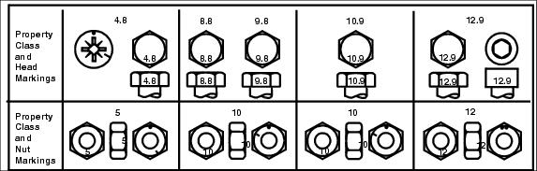
MIF
 | Class 4.8 |  |  |  | Class 8.8 or 9.8
 | Lubricateda |  | Drya |  | Lubricateda |  | Drya
Size | N·m | lb-ft | N·m | lb-ft | N·m | lb-ft | N·m | lb-ft
M6 | 4.8 | 3.5 | 6 | 4.5 | 9 | 6.5 | 11 | 8.5
M8 | 12 | 8.5 | 15 | 11 | 22 | 16 | 28 | 20
M10 | 23 | 17 | 29 | 21 | 43 | 32 | 55 | 40
M12 | 40 | 29 | 50 | 37 | 75 | 55 | 95 | 70
M14 | 63 | 47 | 80 | 60 | 120 | 88 | 150 | 110
M16 | 100 | 73 | 125 | 92 | 190 | 140 | 240 | 175
M18 | 135 | 100 | 175 | 125 | 260 | 195 | 330 | 250
M20 | 190 | 140 | 240 | 180 | 375 | 275 | 475 | 350
M22 | 260 | 190 | 330 | 250 | 510 | 375 | 650 | 475
M24 | 330 | 250 | 425 | 310 | 650 | 475 | 825 | 600
M27 | 490 | 360 | 625 | 450 | 950 | 700 | 1200 | 875
M30 | 675 | 490 | 850 | 625 | 1300 | 950 | 1650 | 1200
M33 | 900 | 675 | 1150 | 850 | 1750 | 1300 | 2200 | 1650
M36 | 1150 | 850 | 1450 | 1075 | 2250 | 1650 | 2850 | 2100

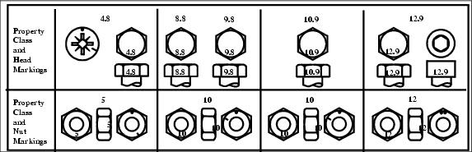
MIF
 | Class 10.9 |  |  |  | Class 12.9
 | Lubricateda |  | Drya |  | Lubricateda |  | Drya
Size | N·m | lb-ft | N·m | lb-ft | N·m | lb-ft | N·m | lb-ft
M6 | 13 | 9.5 | 17 | 12 | 15 | 11.5 | 19 | 14.5
M8 | 32 | 24 | 40 | 30 | 37 | 28 | 47 | 35
M10 | 63 | 47 | 80 | 60 | 75 | 55 | 95 | 70
M12 | 110 | 80 | 140 | 105 | 130 | 95 | 165 | 120
M14 | 175 | 130 | 225 | 165 | 205 | 150 | 260 | 109
M16 | 275 | 200 | 350 | 225 | 320 | 240 | 400 | 300
M18 | 375 | 275 | 475 | 350 | 440 | 325 | 560 | 410
M20 | 530 | 400 | 675 | 500 | 625 | 460 | 800 | 580
M22 | 725 | 540 | 925 | 675 | 850 | 625 | 1075 | 800
M24 | 925 | 675 | 1150 | 850 | 1075 | 800 | 1350 | 1000
M27 | 1350 | 1000 | 1700 | 1250 | 1600 | 1150 | 2000 | 1500
M30 | 1850 | 1350 | 2300 | 1700 | 2150 | 1600 | 2700 | 2000
M33 | 2500 | 1850 | 3150 | 2350 | 2900 | 2150 | 3700 | 2750
M36 | 3200 | 2350 | 4050 | 3000 | 3750 | 2750 | 4750 | 3500

DO NOT use these values if a different torque value or tightening procedure is given for a specific application. Torque values listed are for general use only and include a 10% variance. Check tightness of fasteners periodically. DO NOT use air powered wrenches.
Shear bolts are designed to fail under predetermined loads. Always replace shear bolts with identical grade.
Fasteners should be replaced with the same grade. Make sure fasteners threads are clean and that you properly start thread engagement. This will prevent them from failing when tightening.
When bolt and nut combination fasteners are used, torque values should be applied to the NUT instead of the bolt head.
Tighten toothed or serrated-type lock nuts to the full torque value.
a "Lubricated" means coated with a lubricant such as engine oil, or fasteners with phosphate and oil coatings. "Dry" means plain or zinc plated without any lubrication.

Unified Inch Bolt and Cap Screw Torque Values
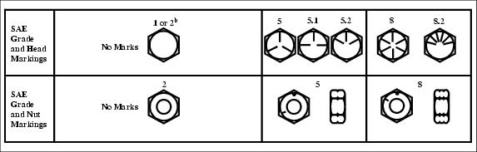
MIF
 | Grade 1 |  |  |  | Grade 2^{b}
 | Lubricatedª |  | Dryª |  | Lubricatedª |  | Dryª
Size | N·m | lb-ft | N·m | lb-ft | N·m | lb-ft | N·m | lb-ft
1/4 | 3.7 | 2.8 | 4.7 | 3.5 | 6 | 4.5 | 7.5 | 5.5
5/16 | 7.7 | 5.5 | 10 | 7 | 12 | 9 | 15 | 11
3/8 | 14 | 10 | 17 | 13 | 22 | 16 | 27 | 20
7/16 | 22 | 16 | 28 | 20 | 35 | 26 | 44 | 32
1/2 | 33 | 25 | 42 | 31 | 53 | 39 | 67 | 50
9/16 | 48 | 36 | 60 | 45 | 75 | 56 | 95 | 70
5/8 | 67 | 50 | 85 | 62 | 105 | 78 | 135 | 100
3/4 | 120 | 87 | 150 | 110 | 190 | 140 | 240 | 175
7/8 | 190 | 140 | 240 | 175 | 190 | 140 | 240 | 175
1 | 290 | 210 | 360 | 270 | 290 | 210 | 360 | 270
1-1/8 | 470 | 300 | 510 | 375 | 470 | 300 | 510 | 375
1-1/4 | 570 | 425 | 725 | 530 | 570 | 425 | 725 | 530
1-3/8 | 750 | 550 | 950 | 700 | 750 | 550 | 950 | 700
1-1/2 | 1000 | 725 | 1250 | 925 | 990 | 725 | 1250 | 930

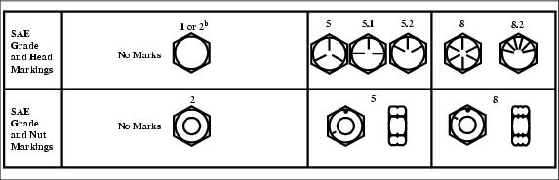
MIF
 | Grade 5, 5.1, 5.2 |  |  |  | Grade 8 or 8.2
 | Lubricateda |  | Drya |  | Lubricateda |  | Drya
Size | N·m | lb-ft | N·m | lb-ft | N·m | lb-ft | N·m | lb-ft
1/4 | 9.5 | 7 | 12 | 9 | 13.5 | 10 | 17 | 12.5
5/16 | 20 | 15 | 25 | 18 | 28 | 21 | 35 | 26
3/8 | 35 | 26 | 44 | 33 | 50 | 36 | 63 | 46
7/16 | 55 | 41 | 70 | 52 | 80 | 58 | 100 | 75
1/2 | 85 | 63 | 110 | 80 | 120 | 90 | 150 | 115
9/16 | 125 | 90 | 155 | 115 | 175 | 130 | 225 | 160
5/8 | 170 | 125 | 215 | 160 | 215 | 160 | 300 | 225
3/4 | 300 | 225 | 375 | 280 | 425 | 310 | 550 | 400
7/8 | 490 | 360 | 625 | 450 | 700 | 500 | 875 | 650
1 | 725 | 540 | 925 | 675 | 1050 | 750 | 1300 | 975
1-1/8 | 900 | 675 | 1150 | 850 | 1450 | 1075 | 1850 | 1350
1-1/4 | 1300 | 950 | 1650 | 1200 | 2050 | 1500 | 2600 | 1950
1-3/8 | 1700 | 1250 | 2150 | 1550 | 2700 | 2000 | 3400 | 2550
1-1/2 | 2250 | 1650 | 2850 | 2100 | 3600 | 2650 | 4550 | 3350

DO NOT use these values if a different torque value or tightening procedure is given for a specific application. Torque values listed are for general use only and include a 10% variance. Check tightness of fasteners periodically. DO NOT use air powered wrenches.
Shear bolts are designed to fail under predetermined loads. Always replace shear bolts with identical grade.
Fasteners should be replaced with the same grade. Make sure fasteners threads are clean and that you properly start thread engagement. This will prevent them from failing when tightening.
Tighten toothed or serrated-type lock nuts to the full torque value.
a"Lubricated" means coated with a lubricant such as engine oil, or fasteners with phosphate and oil coatings. "Dry" means plain or zinc plated without any lubrication.
^{b}"Grade 2" applies for hex cap screws (not hex bolts) up to 152 mm (6-in.) long. "Grade 1" applies for hex cap screws over 152 mm (6-in.) long, and for all other types of bolts and screws of any length.

